Dear Gering Resident:

The City of Gering and Waste Management have teamed up to provide residents the opportunity to have single-stream recycling collection at your residence.

How can I get started?

Call (308) 436-7568 to sign up. The cost for the service is $4.30 per month for every other week pickup of a 96 gallon container. The charges will be added to your monthly utility bill should you decide to participate. Your blue recycling cart will be delivered as they become available. The cart will be emptied every other week on Wednesday. The City will be split in half down the middle of ‘Q’ Street and everything north will be picked up one week (N week) and everything south will be picked up on the other (S week) Please have your recycling container at the curb by 6:30 a.m. for collection. Continue to use the brown/tan cart or alley container for trash. The green containers are for yard waste only and will only be emptied from May 1 to October 31 each year. Commercial recycling containers are available as well. Call for details.

What can I recycle?

Look for specific details inside this brochure on what items can be recycled.

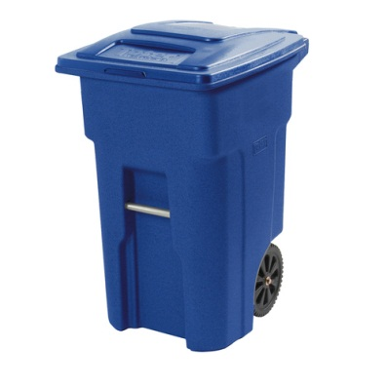
Your Cart Identification
Number is:

Your Collection Days Are:

Wednesday _____ week

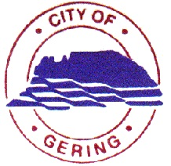

CITY OF GERING
Sanitation Department
PO Box 687
Gering, NE 69341
(308) 436-7568
Fax: (308) 436-5692

Single-Stream
Recycling
Program

The City of Gering and
Waste Management
are teaming up to provide
Single-Stream recycling
Services to the residents
of Gering. The service
is offered at a cost of
$4.30 per month.

Single – Stream Recycling
This means you can put all of your recyclables together, no sorting needed! Use your blue cart to place all your standard recyclables together. In order to ensure pick-up, your recycling cart must be properly placed in the collection area by 6:30 a.m. on your scheduled collection day. Your collection cart must be removed from its collection area by 6:00 p.m. Your cart should be at least ten feet away from any vehicle or other obstacle (mailbox, tree, fence, driveway edge if blocked, etc.) in order to give the automated truck proper clearance for dumping the cart.
Comingled accepted materials are as follows:

OTHER MATERIALS WHICH ARE NOT ACCEPTED INCLUDE BUT ARE NOT LIMITED TO: Glass of any type; Plastic bags of any type; Used paper towels, tissues; Used paper plates, cups etc.; Metallic wrapping paper; Wax paper; Laminated paper; Any paper contaminated with food waste; Shredded paper; Styrofoam (cups, plates, bowls, to-go containers and foam packing of any kind); Materials contaminated with food waste/grease; Trash/Food waste; Plastic film (such as candy wrappers, zip lock bags, sandwich bags); Plastic cutlery (forks, knives, spoons); Glass cookware; Plate glass; Window glass; Motor oil containers, Ceramics; Construction and Demolition Materials; Wood; Vinyl siding.

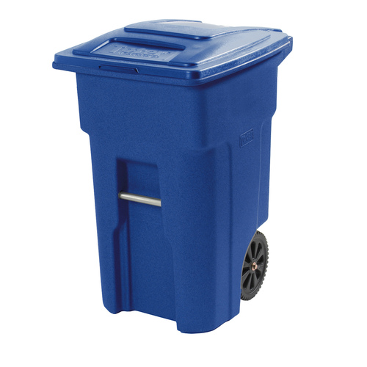

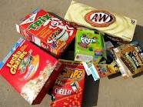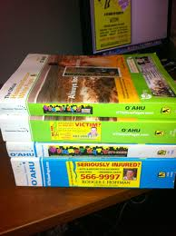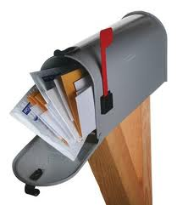
Food Boxes / Boxboard Newspapers Brown Paper Bags Phone Books, Books, Junk Mail
Like empty cereal boxes Catalogs and Magazines

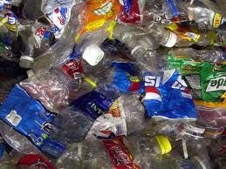 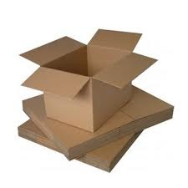 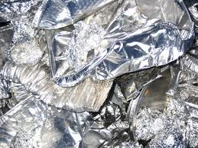 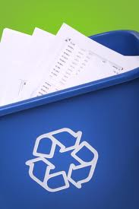 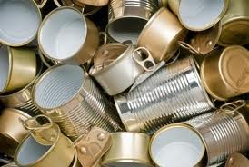Plastic Bottles and Containers #1-#7 Cardboard Aluminum Foil & Trays Office & School Paper Cans
Plastic Bottles (6+ oz.) Tubs (4+ oz.) Collapse boxes Tin & Aluminum Including Buckets (5 gl. or less) Cut down to 3’ x 3’ or less caps and lids

NO GLASS OF ANY KIND

NO PLASTIC BAGS OF ANY KIND

